**Data Structures and Algorithms**

**Lab Report**

**Lab08**



|  |  |
| --- | --- |
| Group Members Name & Reg #: | **Muhammad Haris Irfan**  **(FA18-BCE-090)** |
|  |  |
| Class | Data Structures and Algorithms CSC211 (**BCE-3B**) |
| Instructor’s Name | Dilshad Sabir |

**In Lab Tasks**

**Task:1**

**Complete the functions for Selection Sort and Insertion Sort**

**Solution:**

The code is shown below,

Selection Sort:

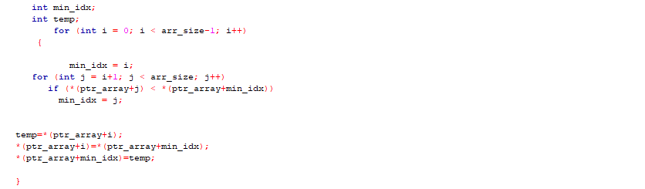

The Result of the following code is attached below:

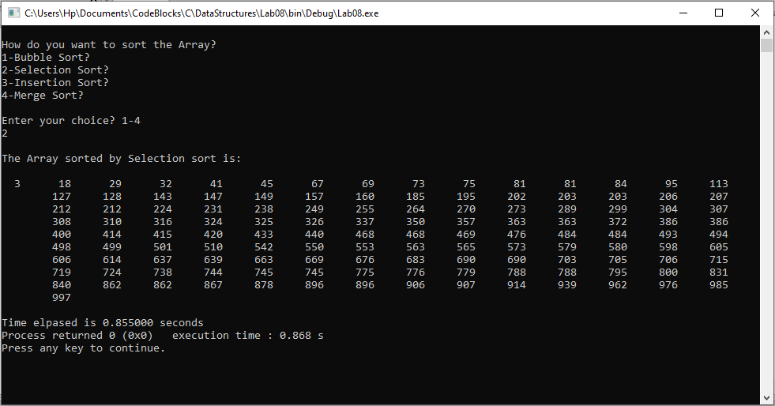

Insertion Sort:

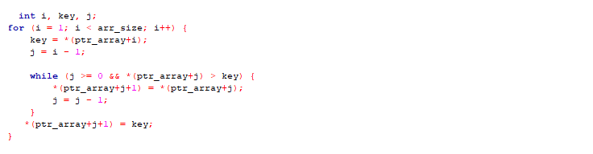

The Result of the following code is attached below:

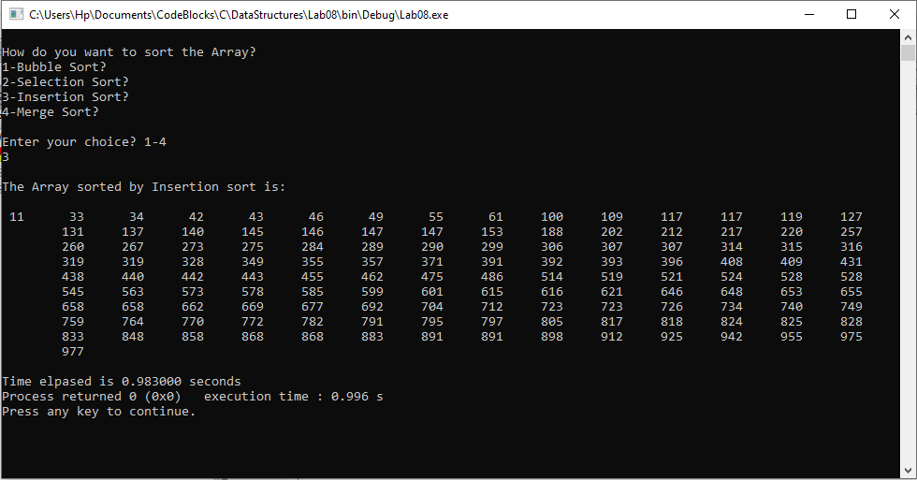

-------------------------------

**Task:2**

**Empirically compute the execution times for the three sorting methods**

**Solution:**

We calculated the execution time of each type, by varying the Data size, the calculations are filled in the table below.

|  |  |  |  |  |
| --- | --- | --- | --- | --- |
| **Data Size** | **Bubble Sort** | **Selection Sort** | **Insertion Sort** | **Merge Sort** |
| 16 | 1.14s | 1.74s | 0.90s | 0.74s |
| 128 | 0.90s | 0.84s | 0.58s | 0.47s |
| 1024 | 1.26s | 1.46s | 1.10s | 0.64s |
| 16384 | 2.86s | 2.55s | 2.43s | 1.78s |
| 131072 | 55.18s | 29.88s | 21.12s | 11.7s |

-------------------------------

**Post Lab Task.**

**Task 3:**

**Complete the Merge Sort Function and empirically determine its time complexity.**

Solution

The code is shown below,

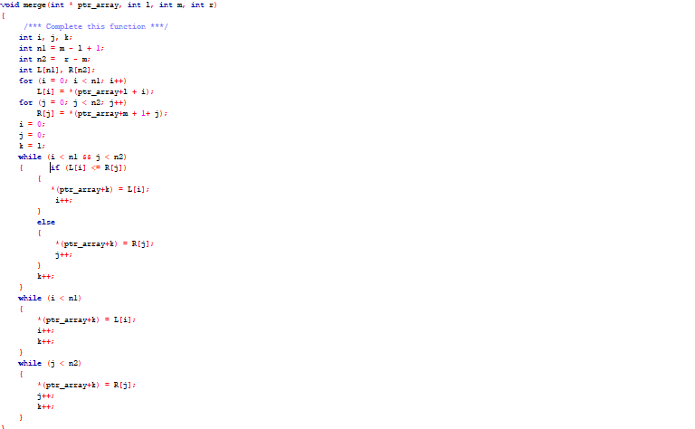

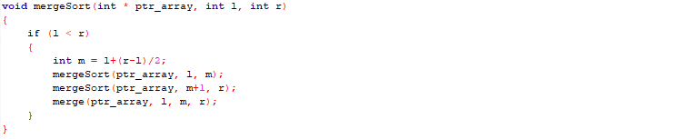

The Result of the following code is attached below:

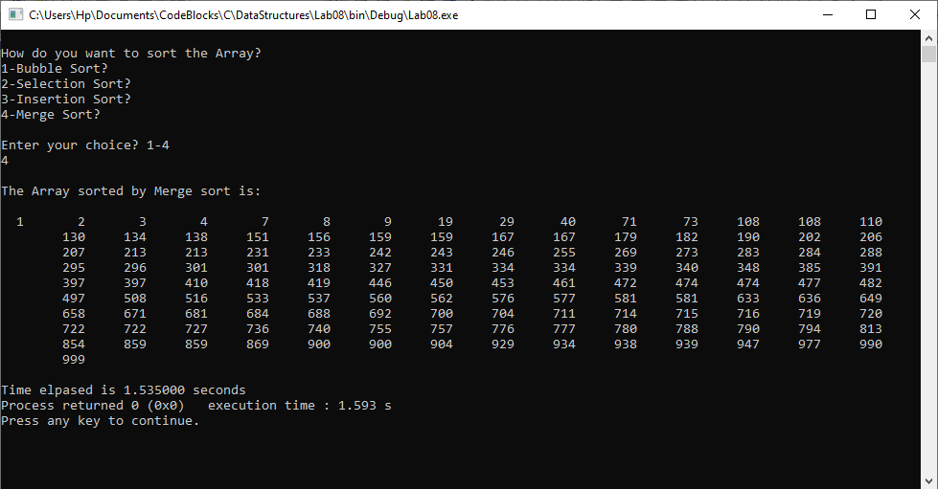

|  |
| --- |
| **Merge Sort** |
| 0.74s |
| 0.47s |
| 0.64s |
| 1.78s |
| 11.7s |

|  |
| --- |
| **Data Size** |
| 16 |
| 128 |
| 1024 |
| 16384 |
| 131072 |

The time of merge sort is already mentioned in task 2 table, though I will mention it here again,

------------------------------

THE END